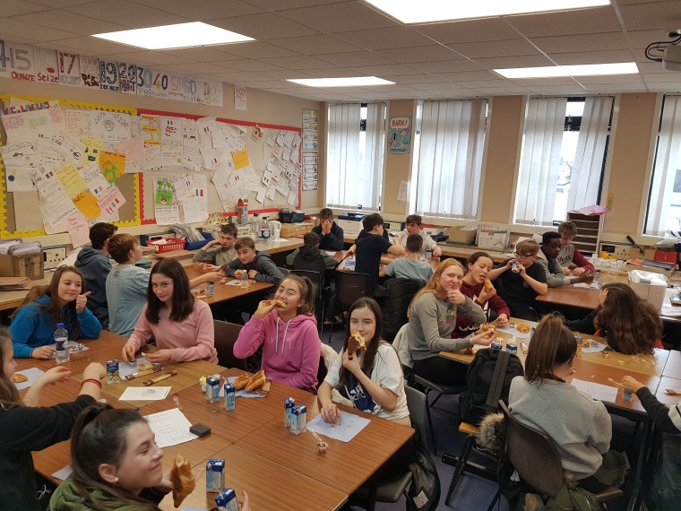
UN petit déjeuner

Français

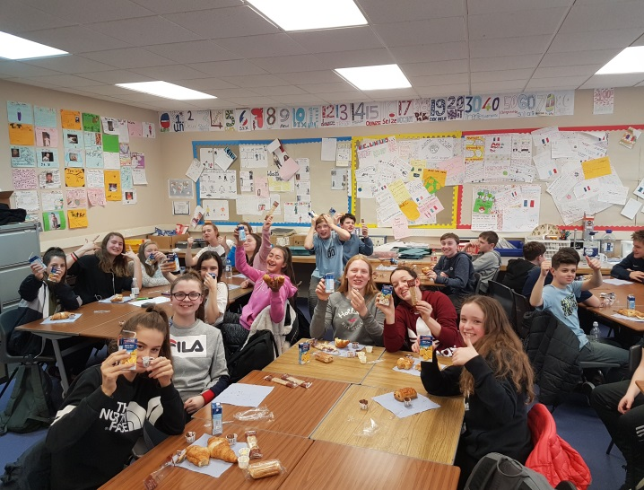
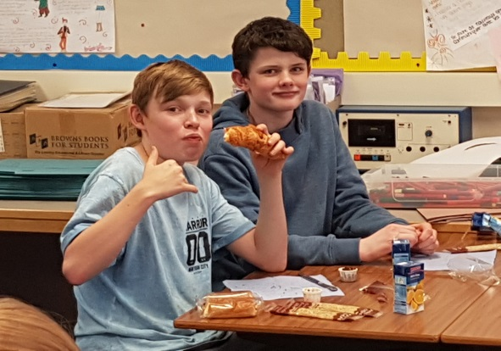
Lundi 5 février et mardi 6 février saw the return of our annual S2 French Breakfast event.


Croissant
(avec du nutella/ du beurre ou de la confiture)
Pain au chocolat
Crêpe chocolat
Jus de pomme
Jus d’orange


Pupil comments:
“It was really tasty, can we do it again next period ?”
“It was good to learn about foods and then eat some of the food that we learned about”
“I think this is a good idea because you remember that learning French is not just about learning words in a class but also about foods and music and dancing and the culture of somewhere different”.
Un grand merci à tous les participants.

